Identification of coefficients and important sectors: comparison of the productive structure of Mexico and Brazil.
Eric R Hernández.
Omar Peredo Aquino.
Jair M Soto.
Itzel Vázquez López.

Abstract.

In this article, we present a comparison of production structures between Brazil and Mexico. These economies are the largest in Latin America representing up to 70% of national income in the region. To make these comparisons, we employed input-output matrices available for both countries in the years 1980 and 2005 (in the case of Mexico for 2003). These matrices were harmonized to an aggregation of 39 sectors, which is the highest compatibility that can be obtained.
The period between 1980 and 2005, reveal changes in development strategies followed in both economies from the period that concludes the so called ISI model, i.e. an import substitution industrial development. We present a set of measures and graphs that portray those economies. From the mid-80s, the authorities of both economies adopted measures that substantially modified the model of development until then prevailing, as a result of macroeconomic instability in those years. The new model include a series of macroeconomic measures that emphasize decreasing state involvement in the economy; removing exchange controls; removing trade barriers; a new structure of public finances that emphasize a balanced budget, and other measures that have been synthetically referred to as the "neoliberal model" (NM).
The tools for making comparisons in the structures of the economies of Mexico and Brazil are based on the estimation of important coefficients (ICs) and important sectors (ISs) following the methodology proposed by Joachim Schintke and Reine Staglin (1988); in the same article, the authors proposed the use of their methodology for input-output tables normalized both by columns and rows. We interpret a particular set of ICs as a graph and obtained for it several social networks indicators. Also, the Tolerable Limits approach of Schintke and Stagling methodology, allowed us to apply a connectivity test of the graph in order to tune the parameters of the method and get a better portrait of the studied economies.
The level of economic integration in a country is characterized by its concentration of ICs, which determine the fundamental economic structure of such a country. A country with a relatively high number of ICs spread across the network of inter-sectoral relationships is likely to be highly integrated.

Keywords: significant coefficients, important sectors, connectivity, graphs and productive structure.
Introduction.
An economic structure can be defined as the set of productive sectors; these sectors are interrelated through flows of intermediate demand. The change of economic paradigm is reflected in this production structure, either by changes in supply or demand for intermediate goods of domestic industries modified by the new form of international economic integration.
The purpose of this paper is to compare inter-temporally relevant sectors and significant coefficients for Brazil and Mexico economies. These economies are the most important in Latin America.
The qualitative analysis in this article is based on the use of domestic and total matrices of Mexico for 1980 and 2003 obtained from the National Institute of Statistics, Geography and Informatics (INEGI); and domestic and total matrices Brazil for 1980 and 2005 obtained from the Brazilian Institute of Geography and Statistics (IBGE). Your comparison over time can show changes in their production structures due to changes in their economic and social policies.
Mexico stands out because of the various reforms undertaken by the government and country capacity to lead trade negotiations such as the Pacific Alliance or The Trans-Pacific Partnership, which contrasts with the loss of competitiveness of Brazil and its stagnant economic growth; so in the first section of work refers to a historical-economic analysis of both countries to understand the context in which develop during the period 1980-2005.
The framework is the model input-output (IO), which provides tools for analysis of productive structures. In the second section of article the techniques used to evaluate the model estimates of Joachim Schintke and Reine Staglin (1988) on the so-called Significant Coefficients (CI), such that control parameters are taken over develops CI.
Subsequently, we will review the feasibility of the simplified representations of productive structures through a graph throw us the CI, the strong connection (direct and indirect relationships between sectors) of the data. This brings us to obtain a graph showing the production structure of each economy with varying degrees of sensitivity, ie, graphs of a matrix and properly smooth or poorly filtered excesses as appropriate.
Schintke and Staglin extend the technique of calculating the CI to estimate important sectors; in this case, instead of taking the individual coefficients, characterized by whole sectors standard are taken. The rationale of this estimate is that although we have a directed graph representing economies as a whole, the relative importance of the sectors is not simply count how many significant coefficients have but to consider all the interactions of a sector with the rest.
In the third section, the results of the calculation are shown CI, SI and related components, so it is expected to obtain in both economies productive structure such that there expressed sectors show viable cutoff level to generate a graph with a high level of connectivity without leaving out important sectors for different levels of sensitivity could incur a breakup. Getting a graph that truly represents the productive structure of the economies.
In the annex we can find the full name of its sectors according to its abbreviation
Finally, conclusions are presented.

Mexico and Brazil in the debt crisis to trade liberalization: different economic results.
In the early 1980s in the major economies of Latin America a derivative crisis model of import substitution industrialization (ISI), called debt crisis is lived, where mainly countries like Argentina, Venezuela, Brazil, Mexico is they were immersed in it.
Brazil and Mexico in accordance with the OECD are the two largest economies in Latin America in terms of trade during the period spanning from 1980 to the present. While it is true that the Brazilian economy is currently undergoing a period of economic contraction, trade structure continues to be buoyant; On the other hand, the Mexican economy is in flux through the implementation of new structural reforms that are expected to be laying the groundwork for further economic growth in the medium and long term.
In the case of Brazil, following the crisis of external debt, the ISI model implemented until the eighties, is displaced and supplanted by trade liberalization due to internal and external factors (Perez et al., 2009). That is why to fit the external crisis that existed, Brazil's macroeconomic policy (fiscal, monetary, trade and exchange) focused on two primary objectives: contracting aggregate demand and modify the behavior of the trade balance of the country. On the one hand, supports and fiscal and financial incentives to specific sectors within the policy called export promotion, it was very tied to the real exchange rate strengthened.
Despite the orthodox macroeconomic policies implemented in Brazil since 1983 due to the debt crisis, the agricultural sector GDP grew at an average annual rate of 3.4% from 1981 to 1989. There are two possible explanations for this shows the priority to be had by the agricultural sector and the second focused on the devaluation of the real exchange rate. The main products of agriculture, both for domestic consumption and export are: soybeans, orange, sugar, snuff, cocoa, coffee, cotton (export) and wheat, corn, rice, cassava and beans (domestic consumption).
We must remember that the foreign trade policy begins to have significant transformations, performed in three stages over the period 1988 to 1994. The Brazilian trade liberalization began in the late eighties and reaching its peak in the early nineties was gradual and discriminatory, achieving mitigate impacts that could affect the industry and its strategic sectors. With the creation of the Southern Common Market (MERCOSUR) regional trade interest acquired through the acquisition of economies of scale and learning on the export of more technologically complex goods.
Productive development programs of completeness articulated infrastructure programs, health and education, promoted industrial upgrading, export expansion and fostering innovation. In addition to the implementation of the Industrial, Technological and Foreign Trade of Brazil (PITCE) whose orientation is focused on these goals, which in turn served to formulate and coordinate industrial policies to stimulate competitiveness (Ferraz et al., 2010).
By maintaining macroeconomic inflation targeting policy, inflation levels and at the same time, the investment rate and price competitiveness of the industry were relatively low, thereby weakening the expected results of development programs. For 2008 the Productive Development Policy (PDP) that seeks to address the flaws shown by the PITCE was implemented.
The strategic sectors, fastest growing and most technologically dynamic Brazil for the period 1993-2008 were: other transportation equipment, machines for desktop and other computer equipment, machinery and electrical equipment, watches and medical instruments, motor vehicles, trailers and trailers, and machinery and equipment. Other transportation equipment and machines desktop and other computer equipment were strongly stimulated by public policies, due to the implementation of a strategy that promotes knowledge intensive and inducing technological change transverse level (software, IT services areas, biotechnology and nanotechnology). Furthermore, it has also strengthened support for capital goods industry.
The liberalization of the Brazilian economy gradually gave, favoring sectors: automotive complex, computer and electronic products, textiles and footwear, certain branches of capital goods, and naval and aviation industry. These sectors are privileged in order to protect local production. In addition, since 2000 a railway strategy to promote exports through pre and post-finance sectors whose activities are intensive and knowledge by the National Development Bank (BNDES) and Brazil Bank is pursued
Brazil is the only country in Latin America that produces significantly capital goods as various government measures (grants, constraints, funding, etc.) so allowed despite trade liberalization. The telecommunications, oil and aviation industry sectors were the most significant. The Brazilian economy has maintained high levels of investment and development (R & D) as a percentage of GDP in relation to Latin American countries.
In the case of Mexico, by the year 1982 experienced its first major economic crisis of the twentieth century, the so-called debt crisis, the ISI model had reached its limits since the early 1970s; however, the government postponed over a decade based on increased external debt and the great discoveries of oil wells.
The Mexican government's strategy to address this crisis was an orthodox stabilization program to rapidly reduce the deficit and restore price stability and balance of payments; ie based on the production of tradable, always within a framework of macroeconomic stability, until mid-1985 trade adjustment The result derived from this program was a drastic reduction of the trade deficit and the current account, but failed to stabilize domestic and creating backward and forward inflation because Mexican exports began to rely increasingly on the use of foreign intermediate inputs, which caused long-term economy is inserted into a path economic expansion.
The failure of orthodox program is given in 1987 with a shift towards an increasingly radical reform in favor of trade liberalization, but combined with a different approach to price stability, so, starts an unorthodox plan, called Economic Solidarity Pact between the government, unions and employers, aimed at stopping inflation quickly through a combination of price and wage control, and freeze the nominal exchange rate and strict fiscal and monetary policy, accompanied privatization of much of the public enterprises, reducing public sector presence in the economy, the opening of the financial and commercial sector this involved a greater share of manufactures in exports and thereafter its rapid growth.
With the heterodox program I manage inflation and stabilize the economy that led to overvaluation of the real exchange rate that was corrected abruptly in 1994-1995 reagents. The stabilization of macroeconomic variables had gotten in early 1990s; however, this was carried coast to deprive economic growth is reflected in a sharp drop in living standards of the population.
The 1990 Mexican is marked in trade with the signing of the Free Trade Agreement with North America (NAFTA) in 1993 apoteotico this event comes from the inertia of the economic reforms of Mexican trade liberalization and this ensured the liberalization process Mexican trade in the long term; the truth is that low technological innovation, shortage of long-term funding and insufficient investment to modernize machinery and equipment, not life developed platform manufactured exports beyond the dependent sweatshop free entry tax temporary imports for subsequent re-export.
Until today the intense and sustained import penetration in the domestic market weakens towing capacity of the export sector to the rest of the economy and that even if manufactured exports these are highly dependent on imported inputs so reducing local content and reduces linkages with local suppliers.
To make the comparison between the structures fundamental economies of Mexico and Brazil, will be developed in the next section the methodology known as significant coefficients, which allow us to obtain a graph from a dichotomous matrix and to compare the important sectors of both economies.

Estimation of the important coefficients.
Among the different methods for defining and evaluating the significant coefficients, we find that the method tolerable limits introduced by Sekulié (1968) and Jilek (1971), served to extend the calculation of CI by Schintke.
Evaluating the CI is related to the error analysis theory in linear systems. To determine the CI and intermediate transactions related to the sectoral effects of production is calculated on the basis of hypothetical errors in the individual coefficients (Lorenzen 1980, 1985).
The input coefficients and the columns or rows for array transactions are classified according to their influence on the gross value of production.
To perform the analysis, we assume the existence of a matrix of input-output without errors, where inconsistent errors simulations for the coefficients of dummy entry being modified are made. Simulations refer to the model of static Leontief open also know as:
$$x={(I-A)}^{-1}y=Cy$$
Where:
x vector of gross value of production.
y final demand vector.
A (a_{ij}) matrix of technical coefficients.
C (c_{ij}) matrix Leontief Inverse.
i, j = 1, …, n number of economic sectors.
The results of error analysis will be analyzed from two perspectives:
- What deviations in sector gross production are induced within the Leontief model for changes or errors in the matrix of technical coefficients?
- What size errors in the input coefficients are admissible to meet common predefined limits for the relative deviations of sectoral gross output using a constant final demand?
The focus on the individual coefficients makes it possible to formulate the following hypothesis regarding the analysis of error:
- If the absolute value of the error rate of a coefficient input
$a_{ij}= {x_{ij}}/{x_{i}} ≠0 \left(1≤i, j ≤n\right)$, is limited by $r_{ij}(p={100p}/{W^{\left(ij\right)}}\left(p\right) for p>0 with:$

$$W^{ij}\left(p\right)=a_{ij}\left(c_{ij}p+100\begin{matrix}max \\ k=1,…, n\end{matrix} {c_{ki}x_{i}}/{x_{k}}\right)= a_{ij}\left(c_{ij}p+100 {c_{ki}x_{i}}/{x_{k}}\right)$$
Then there is greater relative errors p percent they occurred at any gross value of sectoral production $x_{k} \left(k=1, …, n\right).$ In the above equation, $W^{ij}$represents the degree of importance $r_{ij}$ and sensitivity $a_{ij}.$
Each coefficient output $a_{ij}$ can be characterized by the degree of importance $W^{ij}\left(p\right)≥0 with p >0$reflecting the influence coefficients in the gross value of sectoral production.
Assuming that p is positive and is considered less than 100%, the degree of importance can be calculated approximately by:
$$W^{ij}\left(p\right)≈ o_{ij}c_{ij}\left(∂_{ij}p+100\right)≈100o_{ij}c_{ij}$$
Using the output coefficient $o_{ij}={x_{ij}}/{xi} y ∂_{ij}=1 for i=j otherwise equal to 0$
Therefore, it follows that the importance of a coefficient within a row input is approximately proportional to the coefficient corresponding to the input intermediate output absolute. Reflecting the importance of sector j buying industry for sector i.
The considerations presented in this section lead to important and unimportant sectors. An intermediate input or intermediate transaction, not being zero, or corresponding to the input coefficients can be defined as significant if the error rate of the sector is less than 100% and their sensitivity is $r_{ij}<100\%$, second If an intermediate input is characterized by a range considered error or a high degree of sensitivity $r_{ij}≥100\%$ may be classified as unimportant.
The error limit p can be specified according to the aggregation of input-output table, referring to the proposal by Schintke (1976) and Katzenbeisser (1979). Empirical analysis shows that it is advisable to use a percentage p allowing significant coefficients included 90% of total domestic intermediate transactions.

Important sectors.
The influence of errors in the columns or rows of the coefficient matrix input in gross output for selected sectors can be calculated. This results in a classification of columns or rows according to their importance.
In this section, we will focus only on the analysis of the important sectors of the coefficient matrices of input and intermediate inputs.
The absolute errors individually $F_{j}$ fixed in column $A_{j}(1 ≤j≤n)$ of the input coefficient matrix A being taken into account. Now it is possible to formulate the following thesis:
- If the relative amount of error of the Euclidean norm $100\left\|F_{j}\right\|/\left\|A_{j}\right\|$ of an input column j is limited by:
$$r_{j }\left(p\right)=\frac{100p}{W^{\left(j\right)}\left(p\right)} for p>0$$

And the importance of the column is determined by:
$W^{\left(j\right)}\left(p\right)= \left\|A_{j}\right\| (\left\|C_{\vec{J}}\right\| p+100\max_{k=1, …, n}\left\|C_{\vec{k}}\right\| {x_{j}}/{x_{k}})$
The maximum absolute value of the relative errors in gross output production $x_{k} \left(k=1,…, n\right)$ to be percent. This includes additional assumptions for the error vector $F_{j*}A_{j}$ represents the column vector of the matrix A and $C_{\vec{k}}=(c_{k1}, …, c_{kn})$ this represents the row vector k of Leontief inverse. By definition:
$${\left\|F_{j}\right\|}^{2}=\sum_{k=1}^{n}{f_{kj*}^{2}}$$
The impacts of the errors of the individual input columns on production are different. Thus a specific importance $W^{j}\left(p\right)≥0 with p >0$ can be attributed to each $A_{j}$ column as the influence of gross production output.
Assuming a certain percentage limit p a higher value of$W^{\left(j\right)}\left(p\right)$ results in increased importance of column j.
For low p, the importance of the columns can be calculated by:
$$W^{\left(j\right)}=100 \left\|A_{j}\right\| \left\|C_{\vec{M}}\right\|{x_{j}}/{x_{M}}=100 \left\|X_{j}\right\|\left\|C_{\vec{M}}\right\|/x_{M}$$
$(0 <p ≪100)$. Therefore, it follows that
$\frac{\left\|C_{\vec{M}}\right\|}{x_{M}}=$ $\frac{\max_{k=1, …, n}\left\|C_{\vec{k}}\right\|}{x_{k}} y X_{j}= \sum_{i=1}^{n}{x_{ij*}}$
In other words, the importance of the input column $A_{j}$is directly proportional to the sum of the square root of all transactions that column intermediate or approximately proportional to the intermediate transactions sector j (Sell, 1980). This reflects the significance of the sector j buying industry compared to other purchases.

Connectivity.
To review the part that concerns related components that allow us to determine the level of court, in which all sectors are connected with one another. The methodology used is ConnectedComponents, programmed by Mathematica, finding strongly connected components connected; ie sectors with direct and indirect connections.
The study of CI, SI and related components, is estimated to Leontief Inverse and Inverse Ghosh.

Results.
An input-output matrix can be defined as an integrated set of matrices that show the balance between supply and use of goods and services, these matrices provide a detailed analysis of the production process and the use of goods and services occur in a country or region or imported from the rest of the world and the income generated in this production by the various economic activities.
The matrices of input-output components can appreciate arrays offer intermediate demand, final demand and value added vector; so to make the empirical analysis of this article, we will use domestic and import matrices for economies: Mexico, in 1980 and 2003 and Brazil in 1980 and 2005; both approved 39 sectors. To show the coefficients and important sectors Reverse Leontief, which when normalized by column shows the direct and indirect purchases within an economy is created. On the other hand, use the Reverse Ghosh, normalized by row, to show the direct and indirect sales generating the countries analyzed.
Leontief Inverse.
The matrix $(I-A)$ is called Leontief and matrix ${(I-A)}^{-1}$ is called Leontief inverse matrix or matrix of coefficients of direct and indirect requirements per unit of final demand. So, the analysis located productive structures of Mexico and Brazil with those important factors that have a major impact on direct and indirect relations generated by the costs in final demand.
Table 1: Coefficients important domestic and total: 1980, 2003, 2005.
Levels of sensitivity / Country | Mexico 1980 |  | Brazil 1980 |  | Mexico 2003 |  | Brazil 2005
 | Domestic | Total | Domestic | Total | Domestic | Total | Domestic | Total
10 | 32 | 34 | 39 | 44 | 21 | 40 | 31 | 36
20 | 66 | 77 | 68 | 76 | 59 | 86 | 71 | 82
30 | 95 | 105 | 105 | 113 | 90 | 123 | 106 | 123
40 | 123 | 136 | 127 | 143 | 109 | 153 | 147 | 171
50 | 146 | 167 | 156 | 171 | 139 | 187 | 183 | 209
60 | 174 | 191 | 188 | 204 | 161 | 217 | 212 | 240
70 | 198 | 213 | 213 | 231 | 182 | 246 | 246 | 273
80 | 212 | 237 | 237 | 255 | 204 | 275 | 282 | 303
90 | 227 | 249 | 261 | 281 | 219 | 295 | 307 | 327
100 | 239 | 263 | 279 | 302 | 239 | 314 | 330 | 347
Based on data from IBGE and Institute National Statistics, Geography and Informatics (INEGI).
A comparison between the two periods (1980 and 2003.2005) for Mexico and Brazil becomes, shown in Table 1, from the point of view of the direct and indirect effects generated by purchases across sectors, both economies have higher level of integration in recent years, as the total concentration of CI has increased from 263 to 314 to Mexico, and Brazil 302-347.
CI total household comprises foreign CI and CI; ie for the number of CI outsiders simply subtract the total of CI, the CI household. In 1980 shows both economies have a similar percentage of domestic IC. Mexico has 94% and 90% of the total thereof, both for the sensitivity levels of 10 and 100; Furthermore, Brazil has 88% and 92% levels of sensitivity thereof. It is important to remember that both economies during this period still had implemented the so-called model of industrialization through import substitution, which significantly limiting its relations with the outside.
For the following analysis period (2003-2005), the composition of CI is modified significantly for both economies. On the one hand, the Mexican economy has a total of 40 CI, and only 21 belong to domestic CI to a sensitivity level 10; it should be noted that the participation of foreign CI increased to almost half of the total (48 percent). The level of sensitivity of 100, 1 in 4 CI are belonging to the CI outsiders for this economy (24 percent). On the other hand, the Brazilian economy has a composition of 86% and 95% of domestic IC 2005. The Brazilian domestic economy has even strengthened, as their number has increased domestic CI 279-330 at a level of sensitivity 100%; while foreign ratios have decreased from 23 to 17. However, in the Mexican economy opposite has happened in the same level of sensitivity, because even though the number of CI in domestic terms remained unchanged (in both periods 239), the participation of foreign CI increased almost threefold (from 24-75 CI), showing a greater dependence on foreign sector for the integration of the Mexican economy.

Figure 1: Total important coefficients obtained in the levels of sensitivity 10%, 50% and 100%.

Based on data from IBGE and Institute National Statistics, Geography and Informatics (INEGI).

n Figure 1, we show the participation in the productive structure of both domestic and foreign CI. 1980 if the similarity is appreciated in the composition of the structure of Mexico and Brazil. On one hand, the Mexican economy is mostly consists of domestic IC sensitivity level 10 with respect to the Brazilian economy; at a level of 100, Brazil comprises 8% of foreign CI Mexico and 10% of them.
However, in the next period compared involvement CI outsiders becomes more significant for Mexico, as it increases to even 52% stake to a level of sensitivity of 10 and 25% at a level of 100. Meanwhile, Brazil is less dependent on foreign purchases to because their CI foreign decrease by 5% of the production structure to a level of sensitivity of 100, although in other levels of sensitivity participation such IC is greater.
If we analyze growth rates the number of CI outsiders of the Mexican economy to three sensitivity exceeds one hundred percent (850%, 129% and 213% respectively); in contrast, the Brazilian economy is in a completely different situation, and even to the level of sensitivity of the CI 100 foreign decrease (26 percent negative as it passes from 23 in 1980 to 17 in 2005) and for level 10 no growth of these, as for both periods is five.
Therefore, the two economies are largely integrated over the previous period, but together the changes are significant. The production structure of the Mexican economy depends more on the external economy than in previous years, while Brazil's economy has focused more on strengthening its domestic market.
Figure 2: Strongly connected components of the important coefficients for Mexico and Brazil, 1980.

Based on data from IBGE and Institute National Statistics, Geography and Informatics (INEGI).

The strongly connected components (CC) of the Mexican and Brazilian economies allow us to find the level of internal integration and dependence on foreign sector as a cohesive network point and the resemblance between the two countries.
Productive behavior Mexico domestic network at various levels of integration exhibits lower sensitivity compared to the productive Brazil network, noting that in the case of the total productive integration Mexico network is more stable, so that, in Mexico to complement the integration of its productive structure of the external sector participation is necessary.
The behavior of the domestic structure of Mexico and Brazil in 1980 differs because the Brazilian economy has a strongly integrated comparison of Mexican internal network.
Moreover, integration of all productive domestic network and Brazil have similar behavior; ie, the Brazilian economy has a strong domestic market that does not depend on outside.
Both economies show the largest number of sectors connected to the sensitivity level of 70.
Figure 3: strongly connected components of the important coefficients for Mexico 2003 and Brazil, 2005.

Based on data from IBGE and Institute National Statistics, Geography and Informatics (INEGI).

The behavior of the integration of domestic Mexican production network compared with 1980, presents the same variations and the need for external sector to improve the integration of its economy.
Notably, the Brazilian economy in both years has a similar integration, showing a strong domestic integration; however, the share of external sector continues to be important to improve the integration of the Brazilian network.
The Mexican production network at lower levels of sensitivity depends on entirely foreign sector to improve relations between their purchases.

Graph 1: Structure productive of the total matrix Mexico 1980.
(100% sensitivity).
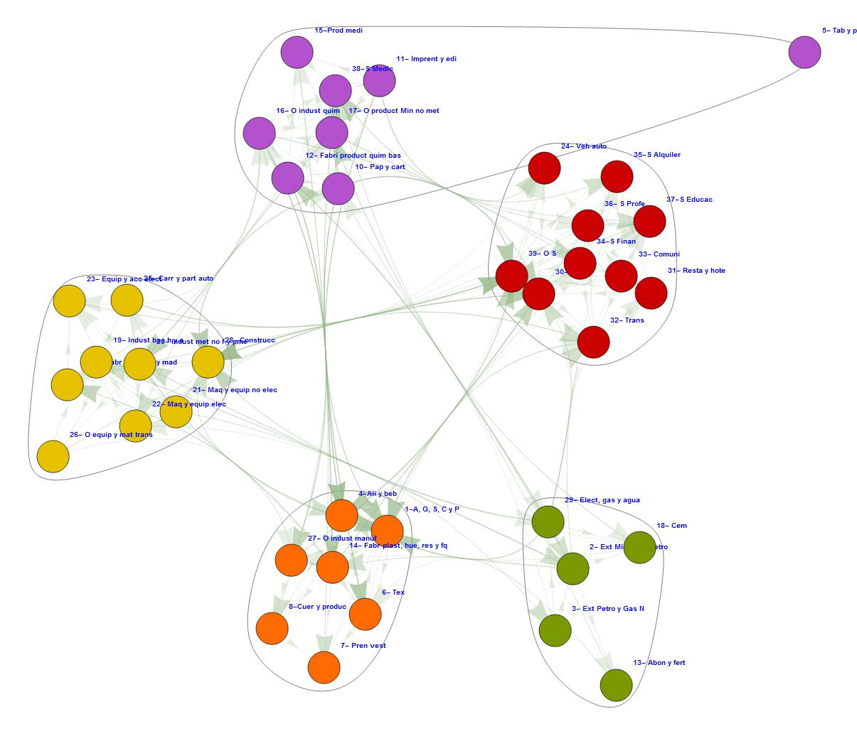
Based on data from IBGE and Institute National Statistics, Geography and Informatics (INEGI).
The above graph is the product of the matrix of 1s and 0s generated the level of sensitivity 100%, we find the 39 sectors of the Mexican economy connected and structured in clusters depending on the greater influence upon each other. In this productive structure Mexico for 1980 are five clusters, two of them (orange and green) belong to the activities of the agricultural sector; Manufacturing activities are located in two clusters (yellow and purple) and a cluster concerning the activities of the service sector (red).
The sector of snuff and products whose location has interested in both the manufacturing cluster as in services. The previous section shows that agricultural and manufacturing sector was relatively diversified and heterogeneous inside.
The activities that have a closer relationship with the rest of the clusters are: agriculture (orange) Agriculture, forestry, hunting and fishing, food and drink, in manufacturing (yellow) is: construction and the service sector: trade. These activities are focused on the domestic market within the model of Import Substitution Industrialization (ISI).
Is pertinent to mention that the existence of a greater number of clusters is not a better productive structure, the less the clusters there is greater integration among activities.

Graph 2: Structure productive of the total matrix Mexico 2003.
(100% sensitivity).
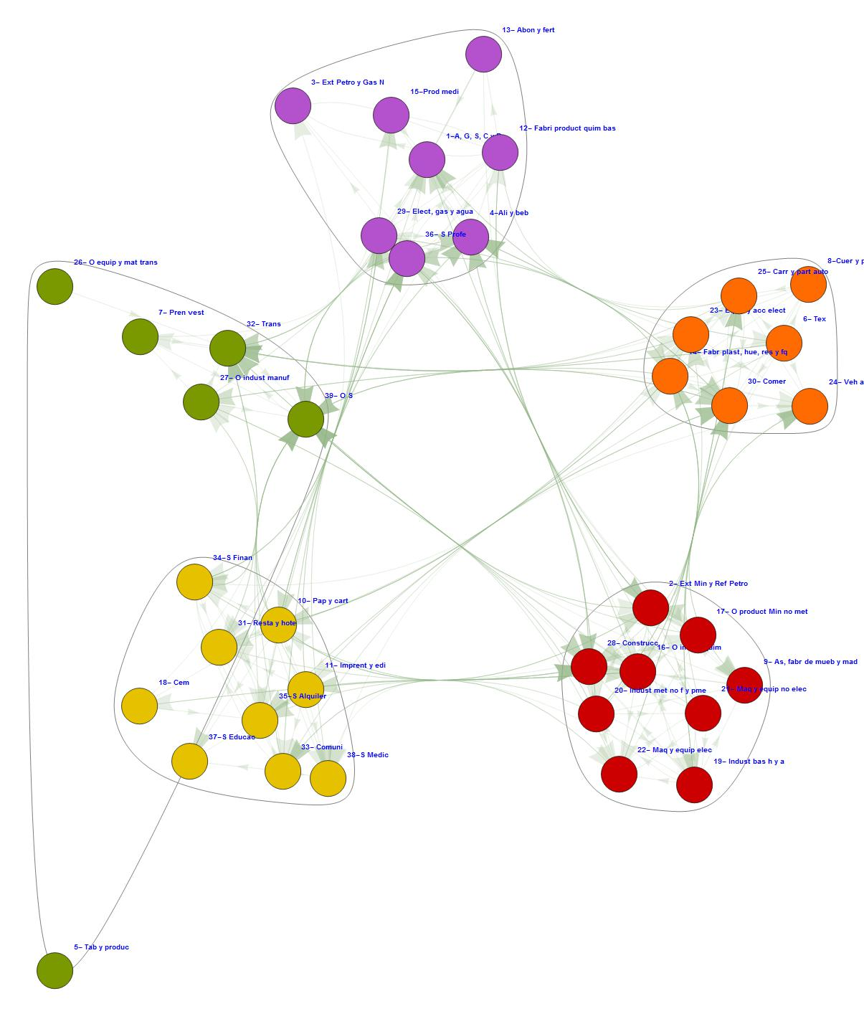
Based on data from IBGE and Institute National Statistics, Geography and Informatics (INEGI).).

The production structure of Mexico for 2003 the number of clusters compared to 1980 not present variation; however, the formation of clusters is different, three manufacturing sectors (green, red and orange), an agricultural sector (purple) and one service (yellow). The snuff and products sector has participation in the cluster services and in manufacturing, as evident in 1980. This re structuring of economic activities oriented towards other clusters, but not a greater dynamism in this production structure.
The activities with the highest ratio of clusters are in the agricultural sector Agriculture, forestry, hunting and fishing, food and beverage, for further manufacturing, transportation and other services, manufacturing (green) (red) mining and refining of petroleum, machinery and electrical and construction equipment manufacturing (orange) trade, to the service sector, restaurants and hotels, communications, financial services, rental services, and medical services.
Comparing the 1980 Mexican production structure this year, the Mexican economy was geared towards strengthening the manufacturing sector; however, this did not present a close relationship with the agricultural cluster, because most inputs are imported which leads to a negative impact on the structure; likewise the agricultural cluster loses prominence with the rest of the clusters due to the detriment of their activities more sharply from trade liberalization. We found a strong relationship between manufacturing clusters and great interaction between the cluster services with the rest of the clusters.
Importantly, the relationships established the cluster service to the whole of the productive structure, and within this the relevance of the medical and financial services, compared with the structure in 1980, had no relationship with the rest of the sectors due to financial globalization in which we are immersed.

Graph 3: Structure productive of the total matrix Brazil 1980.
(100% sensitivity).
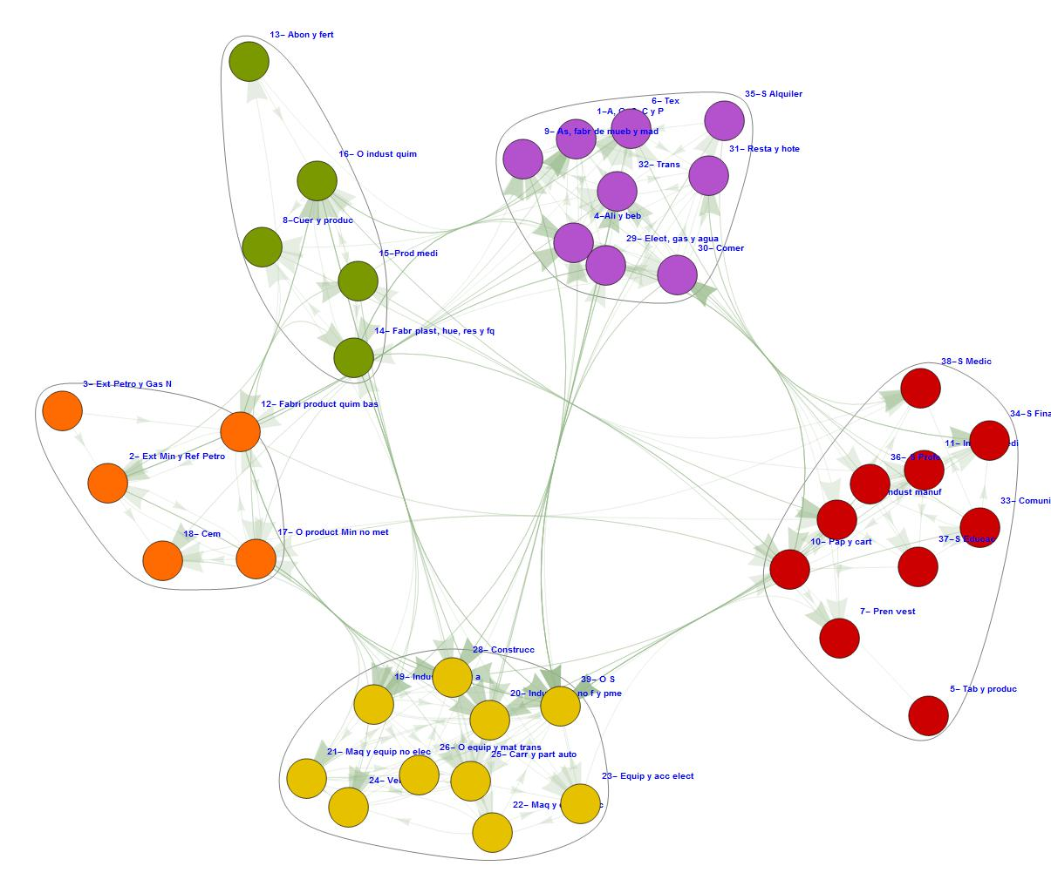
Based on data from IBGE and Institute National Statistics, Geography and Informatics (INEGI).

Of the five clusters formed one exists mainly containing service sectors (red), one including related chemicals (green) areas, one with extractive industries of various products such as oil and natural gas (orange), a cluster's where participate capital goods and related automotive sector (yellow) and a cluster regards food industries (purple) industries. It is reflected relatively homogeneous composition of the economy.
The cluster of capital goods, chemicals and food sector have a closer relationship with the whole productive structure because the Brazilian government implemented a policy of export promotion and application to the mid-1970s to technological industrial policy; similarly in this period a policy of protectionism ultra applied, leading to a decline in imports, creating a more dynamic clusters concerning primary and secondary activities.

Graph 4: Structure productive of the total matrix Brazil 2005.
(100% sensitivity).

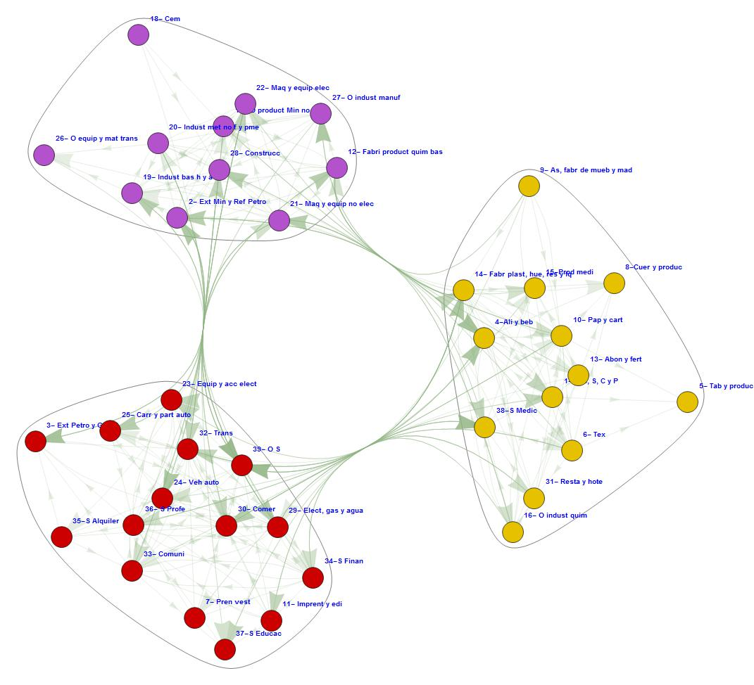
Based on data from IBGE and Institute National Statistics, Geography and Informatics (INEGI).

By 2005 the production structure changes completely, but at the same time it is more consolidated. The three clusters shown are relatively more homogeneous compared with the previous graph, since in them a cluster with industrial sectors (purple), otherwise dominated service sectors (red) and last sectors are related issues is contained food and field.
It is noteworthy, first, that the economy of Brazil protected its strategic sectors once it decides to open up to foreign trade, on the other, that industrial policies were primarily aimed at stimulating growth sectors and technologically dynamic as well as the capital goods industries.
Table 2: Important sectors.
Sectors | Mexico 1980 |  | Brazil 1980 |  | Mexico 2003 |  | Brazil 2005
 | Domestic | Total | Domestic | Total | Domestic | Total | Domestic | Total
1-A, G, S, C y P | 62.6304 | 74.2550 | 100.7541 | 106.8454 | 16.3941 | 66.0777 | 20.9093 | 94.9646
2- Ext Min y Ref Petro | 48.3731 | 57.1939 | 32.8328 | 185.4362 | 48.4441 | 168.6142 | 39.4519 | 233.6274
3- Ext Petro y Gas N | 4.1917 | 5.4770 | 3.1003 | 3.3316 | 6.1864 | 26.2228 | 7.7829 | 37.9543
4-Ali y beb | 254.2006 | 338.4988 | 279.3642 | 319.5050 | 64.9949 | 258.2391 | 74.2869 | 338.1035
5- Tab y produc | 2.9595 | 3.4542 | 5.7753 | 6.1478 | 0.4246 | 1.9188 | 2.9772 | 13.2382
6- Tex | 32.6896 | 39.2165 | 83.9327 | 89.3467 | 2.3573 | 14.4410 | 5.2748 | 26.1978
7- Pren vest | 29.9566 | 35.5627 | 40.8739 | 43.2497 | 3.1273 | 18.9189 | 6.9525 | 33.5084
8-Cuer y produc | 15.0226 | 18.2440 | 12.2959 | 13.1965 | 3.5943 | 15.5806 | 4.4306 | 20.5144
9- As, fabr de mueb y mad | 23.8317 | 29.0294 | 28.1710 | 30.0557 | 4.2027 | 16.5622 | 3.6924 | 16.5062
10- Pap y cart | 17.3941 | 29.5326 | 25.5286 | 27.6261 | 4.6830 | 25.8318 | 5.6964 | 28.3422
11- Imprent y edi | 7.9277 | 12.6220 | 14.1525 | 16.7313 | 1.9849 | 8.7465 | 3.3617 | 17.7524
12- Fabri product quim bas | 11.4375 | 15.1573 | 26.6535 | 32.1056 | 25.8257 | 92.0713 | 9.2833 | 67.1416
13- Abon y fert | 3.0860 | 4.1807 | 14.1925 | 27.8421 | 0.3925 | 2.0369 | 1.7159 | 10.3113
14- Fabr plast, hue, res y fq | 18.5141 | 33.4311 | 54.0411 | 63.4939 | 6.1654 | 36.0970 | 15.5768 | 84.3508
15-Prod medi | 4.9244 | 7.7544 | 7.7728 | 10.4500 | 4.1862 | 17.7342 | 2.1250 | 12.2858
16- O indust quim | 16.1810 | 27.2253 | 17.6766 | 25.2694 | 3.7070 | 18.3290 | 3.2541 | 18.6904
17- O product Min no met | 13.3526 | 16.8698 | 14.4249 | 15.6565 | 4.0028 | 15.4432 | 2.9553 | 14.0215
18- Cem | 4.0463 | 4.6728 | 17.2847 | 18.2736 | 2.6100 | 9.6151 | 0.8228 | 4.0012
19- Indust bas h y a | 49.9003 | 69.6793 | 104.3379 | 113.6656 | 9.9205 | 46.4713 | 9.9277 | 56.1623
20- Indust met no f y pme | 17.7348 | 31.3419 | 68.8691 | 80.7653 | 7.7079 | 36.0538 | 2.8342 | 17.4460
21- Maq y equip no elec | 9.4600 | 16.8856 | 42.0477 | 47.5699 | 2.3927 | 11.1056 | 7.9245 | 38.3493
22- Maq y equip elec | 12.0265 | 16.0879 | 9.2966 | 10.8837 | 3.8382 | 18.5271 | 4.7767 | 23.8364
23- Equip y acc elect | 6.9583 | 11.0316 | 16.9237 | 23.0824 | 3.4120 | 28.4005 | 5.6001 | 56.5859
24- Veh auto | 32.2759 | 65.9315 | 41.1201 | 45.9792 | 19.2413 | 128.9838 | 12.7568 | 76.5765
25- Carr y part auto | 12.2818 | 16.4642 | 39.7751 | 45.6802 | 7.2637 | 37.9599 | 10.7338 | 50.0405
26- O equip y mat trans | 2.9434 | 4.1401 | 8.2273 | 11.0129 | 0.3819 | 3.1431 | 3.9416 | 26.5723
27- O indust manuf | 6.4178 | 9.6183 | 8.1265 | 9.0121 | 1.5724 | 7.1469 | 3.3174 | 15.9940
28- Construcc | 102.6674 | 132.2427 | 103.2089 | 111.3615 | 38.6764 | 146.2255 | 13.5533 | 62.9249
29- Elect, gas y agua | 22.2710 | 25.7388 | 30.4175 | 32.1918 | 15.1459 | 62.0324 | 21.6433 | 104.7300
30- Comer | 65.6522 | 76.3752 | 86.8731 | 92.6226 | 32.5718 | 118.8846 | 16.6304 | 78.2737
31- Resta y hote | 16.3989 | 18.9253 | 41.8341 | 44.7590 | 6.2522 | 21.9273 | 15.1760 | 67.3633
32- Trans | 34.1029 | 50.8332 | 45.1924 | 67.5816 | 25.7871 | 103.3458 | 22.4844 | 102.5220
33- Comuni | 1.4657 | 2.7923 | 3.5476 | 3.9851 | 9.0669 | 34.7933 | 18.3392 | 87.2667
34-S Finan | 9.3550 | 10.8433 | 32.5760 | 36.8792 | 15.2281 | 59.1064 | 19.3441 | 90.7986
35-S Alquiler | 19.9704 | 23.0469 | 42.9876 | 45.4356 | 6.7868 | 23.8488 | 3.1340 | 14.1020
36- S Profe | 8.0217 | 9.2606 | 26.6113 | 30.8411 | 11.3429 | 43.7718 | 13.9572 | 64.6019
37-S Educac | 7.5759 | 8.7614 | 4.4605 | 4.7553 | 3.8482 | 14.0704 | 6.4519 | 29.1337
38-S Medic | 15.2602 | 18.1555 | 12.6657 | 13.6070 | 6.3372 | 25.6044 | 11.2686 | 54.6295
39- O S | 61.2321 | 71.0133 | 130.8361 | 145.3733 | 19.9330 | 72.7125 | 34.8191 | 158.7632
Based on data from IBGE and Institute National Statistics, Geography and Informatics (INEGI).

The above table allows us to know the ordinal value of the sector's importance within the productive network of Mexico and Brazil for the years 1980, 2003 and 2005, respectively. The most representative sectors are in green, the color fade down to red shows a minor.
Table 3: Key important sectors.
Mexico 1980 | Domestic |  | Total | Brazil 1980 | Domestic |  | Total
Ali y beb | 254.2 | Ali y beb | 338.5 | Ali y beb | 279.4 | Ali y beb | 319.5
Construcc | 102.7 | Construcc | 132.2 | O S | 130.8 | Ext Min y Ref Petro | 185.4
Comer | 65.7 | Comer | 76.4 | Indust bas h y a | 104.3 | O S | 145.4
A, G, S, C y P | 62.6 | A, G, S, C y P | 74.3 | Construcc | 103.2 | Indust bas h y a | 113.7
O S | 61.2 | O S | 71.0 | A, G, S, C y P | 100.8 | Construcc | 111.4
Indust bas h y a | 49.9 | Indust bas h y a | 69.7 | Comer | 86.9 | A, G, S, C y P | 106.8
Ext Min y Ref Petro | 48.4 | Veh auto | 65.9 | Tex | 83.9 | Comer | 92.6
Trans | 34.1 | Ext Min y Ref Petro | 57.2 | Indust met no f y pme | 68.9 | Tex | 89.3
Tex | 32.7 | Trans | 50.8 | Fabr plast, hue, res y fq | 54.0 | Indust met no f y pme | 80.8
Veh auto | 32.3 | Tex | 39.2 | Trans | 45.2 | Trans | 67.6
Mexico 2003 | Domestic |  | Total | Brazil 2005 | Domestic |  | Total
Ali y beb | 65.0 | Ali y beb | 258.2 | Ali y beb | 74.3 | A, G, S, C y P | 95.0
Ext Min y Ref Petro | 48.4 | Ext Min y Ref Petro | 168.6 | Ext Min y Ref Petro | 39.5 | Ext Min y Ref Petro | 233.6
Construcc | 38.7 | Construcc | 146.2 | O S | 34.8 | Ext Petro y Gas N | 38.0
Comer | 32.6 | Veh auto | 129.0 | Trans | 22.5 | Ali y beb | 338.1
Fabri product quim bas | 25.8 | Comer | 118.9 | Elect, gas y agua | 21.6 | Tab y produc | 13.2
Trans | 25.8 | Trans | 103.3 | A, G, S, C y P | 20.9 | Tex | 26.2
O S | 19.9 | Fabri product quim bas | 92.1 | S Finan | 19.3 | Pren vest | 33.5
Veh auto | 19.2 | O S | 72.7 | Comuni | 18.3 | Cuer y produc | 20.5
A, G, S, C y P | 16.4 | A, G, S, C y P | 66.1 | Comer | 16.6 | As, fabr de mueb y mad | 16.5
S Finan | 15.2 | Elect, gas y agua | 62.0 | Fabr plast, hue, res y fq | 15.6 | Pap y cart | 28.3
Based on data from IBGE and Institute National Statistics, Geography and Informatics (INEGI).

Table 3, the 10 most important sectors for the economies of Mexico and Brazil are reported, the name of the sectors that coincide in each of the years in black and blue for domestic sectors to total sectors are highlighted.
It is noteworthy that for 1980, both economies agree on the following key sectors: food and beverages in both the domestic and the total, domestic differ as to the Mexican case is of greater importance mineral extraction and oil refining and motor vehicles; unlike with Brazil that diverges in nonferrous metals industry and structured metal products and manufacture of plastic, rubber, resins and chemical fibers. For total, matching all major sectors; is noteworthy that in both cases, domestic and total the most important sectors belong to activities of the primary sector, because in the two countries in 1980 were in the final stages of industrialization model of import substitution.
The important sectors of Mexico and Brazil for the year 2003-2005 respectively, agree domestic and total in the case of food and beverages and mining and oil refining; domestic to Mexico in its conformation is predominant in both sectors within manufacturing, service sector and primary activities and to Brazil in the domestic is mainly composed of activities pertaining to, primary manufacturing and services sector.
The marked differences between the major sectors of Mexico and Brazil can be seen in the column totals, since for major sectors Mexico belong primarily to the manufacturing sector is evident as increased amount of imports for that example is needed, the case food and beverage requires almost four times more imports to operate this activity so is transportation. The conformation of the total Brazilian prominently belongs to the primary sector where only in the case of mining and oil more is required five times more on imports for other important sectors poses no similar case. Compared with 1980, 2003, 2005 we can see in the caption totals important sectors for Mexico in the first instance has a higher composition of important sectors belonging to the primary and in 2003 there is greater participation of sectors within manufacturing but need a larger volume of imports to run; different case with Brazil that by 1980 major sector belong mainly to primary and 2005 not only maintained but increased belonged, unlike Mexico imports for these sectors do not exceed 100% and in some cases are not necessary.

Conclusions.
The implementation of the CI technique allows us to find the key and with the combination of related components production structure, the cleavage that generates a graph showing the highest number of economic sectors connected, which facilitates analysis in other techniques. The location of important sectors gives a more specific investigation of the sectors that are really important and generate a greater impact on final demand, which facilitates the division between domestic sectors and foreign sectors that make up each economy and thus show whether it has a greater dependence on foreign or not.
As we have analyzed is clear that each of these transition step towards trade liberalization differently, the results economies now realize it, while Brazil crossed by periods of sustained economic growth, the Mexican economy has periods very Short of growth that have been interrupted by the crisis of the presidential term and giving prominence to macroeconomic stability over the social welfare situation that has given differently in Brazil giving a primary emphasis on the social aspect, showing that Mexico has a greater dependence on foreign compared to Brazil.
Another important aspect consists on why Brazil is the main export economy in Latin America compared to Mexico, and concludes that while in Brazil has been a great investment promotion in their export sectors being mainly the production of capital goods , which affects high levels of investment and development; in contrast, in the Mexican case an instability in the long term investment and on the other hand, the main Mexican export sector, manufacturing shown, still depend heavily on imports to the foreign market.
The comparative analysis of the coefficients and important sectors of Brazil and Mexico for the years 1980, 2003, 2005 found evidence of similarities between their productive structures, in important sectors for 1980 to be primary focused economies; However, following the end of the model of industrialization through import substitution and trade liberalization in both countries, it is clear that everyone I face these changes differently. On one hand, Mexico moved to be a manufacturing and service economy depends heavily on imports, and Brazil continued to be a primary economy that depends heavily on imports; what has led to present sustainable growth rates in recent years, unlike Mexico that does not have a constant economic growth.

Bibliography.
Baumann, R. & de Paiva Franco, A. M., 2006. La sustitución de importaciones en Brasil entre 1995 y 200. Revista de la CEPAL, Issue 89, pp. 195-209.
Bekerman, M., 1986. Promoción de exportaciones. Una experiencia latinoamericana: el caso de Brasil. Comercio Exterior, 36(5), pp. 424-433.
Bekerman, M. & Dalmasso, G., 2014. Políticas productivas y competitividad industrial. Revista de Economía Política, 34(1), pp. 158-180.
Ferraz, J. C., Pires de Souza, F. & Kupfer, D., 2010. Trayectorias para el desarrollo brasileño, s.l.: Boletín Informativo Techint.
Ferraz, J.C., D. Kupfer y F. Serrano (1999), “Macro/micro interactions: economic and institutional uncertainties and structural change in Brazilian industry”, Oxford Development Studies, vol. 27, Nº 3, octubre.
Instituto Brasileño de Geografía yEstadística
Instituto Nacional de Estadística, Geografía e Informatica
Pérez, M., Schlesinger, S. & Wise, T. A., 2009. Liberalización comercial y agricultura familiar en Brasil. La experiencia de las décadas de los ochenta y noventa. En: M. Pérez, ed. Promesas y peligros de la liberalización del comercio agrícola. s.l.:s.n., pp. 113-135.
Graciada M., Elsa, (2002), El Siglo XX Mexicano, un capítulo de su historia, 1940-1982. Facultad de Economía, UNAM.
Moreno-Brid, Juan Carlos y Ros Bosch, Jaime, (2010), Desarrollo y crecimiento en la economía mexicana :una perspectiva histórica, México, Fondo de Cultura Económica.
Schintke J, Staglin R (1983), Stability of import input coefficients, German Institute for Economic Research, Berlin (West).
Schintke J, Staglin R (1985), Important input coefficients in market transaction tables and production flow tables, German Institute for Economic Research, Berlin (West).
Tarancón, M. Á., Callejas, F., Dietzenbacher, E. & Lahr L., M., 2008. A revision of the Tolerable Limits Approach: Searching for the Important Sectors. Economic System Research, 20(1), pp. 75-95.

Annex.
1-A, G, S, C y P | Agriculture, Forestry, Fishing and Hunting
2- Ext Min y Ref Petro | Mineral extraction and refining of oil
3- Ext Petro y Gas N | Extraction of oil and natural gas
4-Ali y beb | Food and drinks
5- Tab y produc | Snuff and products
6- Tex | Textiles
7- Pren vest | Clothing
8-Cuer y produc | Leather and leather products
9- As, fabr de mueb y mad | Sawmills, furniture and other wood industries
10- Pap y cart | Paper and cardboard
11- Imprent y edi | Printing and publishing
12- Fabri product quim bas | Manufacture of basic chemicals
13- Abon y fert | Fertilizers
14- Fabr plast, hue, res y fq | Manufacture of articles of plastics, rubbers, resins and chemical fibers
15-Prod medi | Medicinal products
16- O indust quim | Other chemical industries
17- O product Min no met | Other non-metallic mineral products, including glass
18- Cem | Cement
19- Indust bas h y a | Basic iron and steel industries
20- Indust met no f y pme | Manufacture of non-ferrous metals and structural metal products
21- Maq y equip no elec | Machinery and no electrical equipment
22- Maq y equip elec | Electrical machinery and apparatus, including appliances
23- Equip y acc elect | Computer and electronic accessories
24- Veh auto | Vehicles
25- Carr y part auto | Bodies and automotive parts
26- O equip y mat trans | Other equipment and transport equipment
27- O indust manuf | Other manufacturing
28- Construcc | Construction
29- Elect, gas y agua | Electricity, gas and water
30- Comer | Trade
31- Resta y hote | Restaurants and hotels
32- Trans | Transport
33- Comuni | Communications
34-S Finan | Financial services
35-S Alquiler | Rental Services
36- S Profe | Professional services
37-S Educac | Education Services
38-S Medic | Medical services
39- O S | Other services

Licenciado (B.A) in Physics, at Facultad de Ciencias-UNAM, eric_h_r@yahoo.com.mx.
Student of Economics, at Facultad de Economía –UNAM, economiaperedo@gmail.com.
Student of Economics, at Facultad de Economía –UNAM, jair.soto2408@gmail.com.
Licenciada (B.A) in Economics, at Facultad de Economía –UNAM, itzax14@gmail.com.
The PDP is considered by some authors as the most advanced effort in Latin America in the design and coordination of industrial policy as Bekerman & Dalmasso (2014).
For more information on the results of the Reverse Ghosh, contact the authors.

